Q1)

<!DOCTYPE html>

<html lang="en">

<head>

    <meta charset="UTF-8">

    <meta name="viewport" content="width=device-width, initial-scale=1.0">

    <title>Q1</title>

</head>

<body>

    <h1>Ahmad Abdul Sattar Ch</h1>

    <h2>F21-9284</h2>

    <p>Hey! I am a student of FAST NUCES currently enrolled in the 6th semester.

        I am from Lahore and one if my hobbies is to lear different musical instruments. i can play a piano, a guitar and a ukulele.

        <br>

    </p>

</body>

</html>

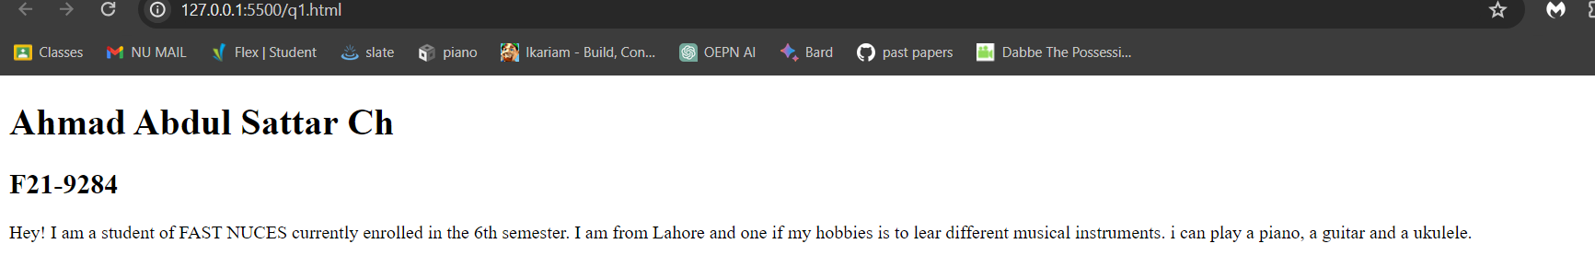

Q2)

<!DOCTYPE html>

<html lang="en">

<head>

    <meta charset="UTF-8">

    <meta name="viewport" content="width=device-width, initial-scale=1.0">

    <title>Q2</title>

</head>

<body>

    <b>This text is bold</b> <br><br>

    <strong>This text is strong</strong> <br><br>

    <big>This text is big</big> <br><br>

    <i>This text is italic</i> <br><br>

    <em>This text is emphasized</em>

    <output>This is computer output</output>

    <p>this is <sub>subscript</sub>and <sup>superscript</sup></p>

</body>

</html>

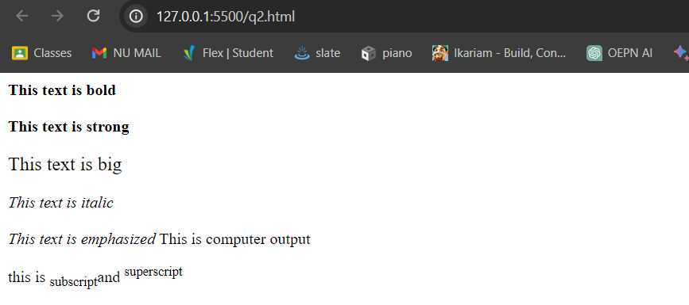

Q3)

<!DOCTYPE html>

<html lang="en">

<head>

    <meta charset="UTF-8">

    <meta name="viewport" content="width=device-width, initial-scale=1.0">

    <title>q3</title>

</head>

<body>

    <img src="nu logo.png" width="1000px" height="1000px" alt="">

</body>

</html>



Q4)

<!DOCTYPE html>

<html lang="en">

<head>

    <meta charset="UTF-8">

    <meta name="viewport" content="width=device-width, initial-scale=1.0">

    <title>q4</title>

</head>

<body>

    <a href="https://www.nu.edu.pk/" target="_blank">

        <img src="nu logo.png" alt="">

    </a>

</body>

</html>

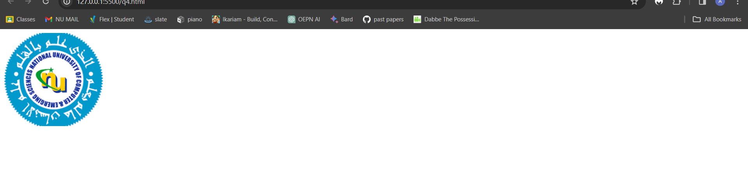



Q5)

<!DOCTYPE html>

<html lang="en">

<head>

    <meta charset="UTF-8">

    <meta name="viewport" content="width=device-width, initial-scale=1.0">

    <title>Q5</title>

</head>

<body>

    <h1>HTML Lists</h1>

    <h2>Unordered Lists</h2>

    <ul>

        <li>Oracle</li>

        <li>Java</li>

        <li>HTML</li>

        <li>CSS</li>

    </ul>

    <h2>Ordered Lists</h2>

    <ol>

        Follow these steps to install java:

        <li>Download the software</li>

        <li>Extract to a folder</li>

        <li>Double click the executable to run</li>

    </ol>

</body>

</html>

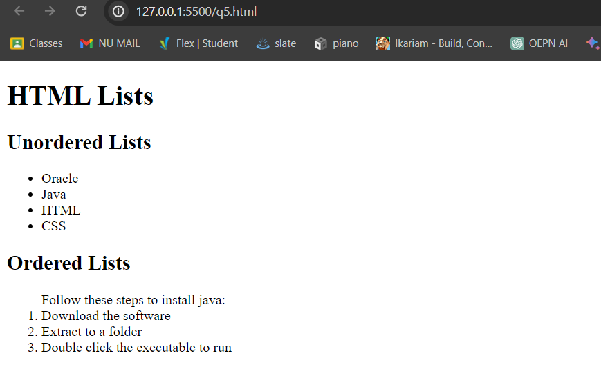

Q6)

<!DOCTYPE html>

<html lang="en">

<head>

    <meta charset="UTF-8">

    <meta name="viewport" content="width=device-width, initial-scale=1.0">

    <title>Q6</title>

    <style>

        table{

            width: 20%;

            border-collapse: collapse;

        }

        th, td {

            padding: 10px;

            border: 1px solid black;

            text-align: center;

        }

    </style>

</head>

<body>

    <table border="1">

        <tr></tr>

            <td rowspan="3">April</td>

            <td></td>

            <td></td>

        </tr>

        <tr>

            <td></td>

            <td></td>

        </tr>

        <tr>

            <td></td>

            <td></td>

        </tr>

        <tr>

            <td></td>

            <td></td>

            <td></td>

        </tr>

        <tr>

            <td></td>

            <td></td>

            <td></td>

        </tr>

    </table>

</body>

</html>

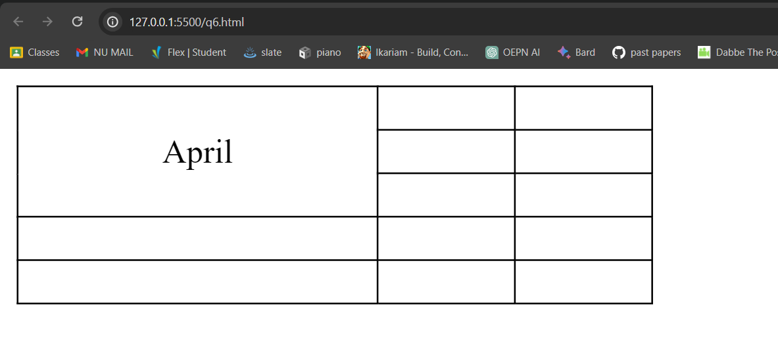

Q7)

<!DOCTYPE html>

<html lang="en">

<head>

    <meta charset="UTF-8">

    <meta name="viewport" content="width=device-width, initial-scale=1.0">

    <title>Q7</title>

    <style>

        table{

            width: 20%;

            border-collapse: collapse;

        }

        th, td {

            padding: 10px;

            border: 1px solid black;

            text-align: center;

        }

    </style>

</head>

<body>

    <table border="1">

        <tr></tr>

            <td colspan="3">2022</td>

        </tr>

        <tr>

            <td></td>

            <td></td>

            <td></td>

        </tr>

        <tr>

            <td colspan="2">Fiesta</td>

            <td></td>

        </tr>

        <tr>

            <td></td>

            <td></td>

            <td></td>

        </tr>

    </table>

</body>

</html>

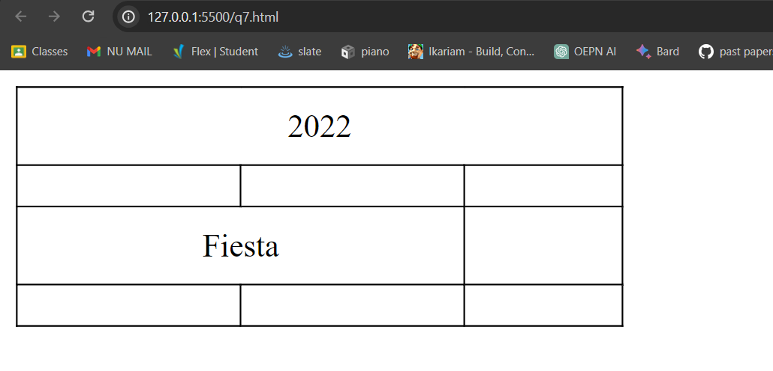

Q8)

<!DOCTYPE html>

<html lang="en">

<head>

    <meta charset="UTF-8">

    <meta name="viewport" content="width=device-width, initial-scale=1.0">

    <title>Q8</title>

    <style>

        form {

            max-width: 400px;

            margin: 170px auto;

        }

        input {

            width: 100%;

            padding: 8px;

            margin-bottom: 15px;

            }

        button {

            padding: 10px;

            background-color: #4caf50;

            color: white;

            border: none;

            border-radius: 4px;

            cursor: pointer;

            margin-left: 100px;

        }

        button[type="reset"] {

            background-color: #f44336;

        }

    </style>

</head>

<body>

    <form action="#" method="post" id="forms">

        <label for="UserName:">UserName:</label>

        <input type="text">

        <label for="email">Email:</label>

        <input type="email">

        <label for="password">Password:</label>

        <input type="password">

        <label for="confirmPassword">Confirm Password:</label>

        <input type="password">

        <button type="submit">Submit</button>

        <button type="reset">Reset</button>

    </form>

</body>

</html>

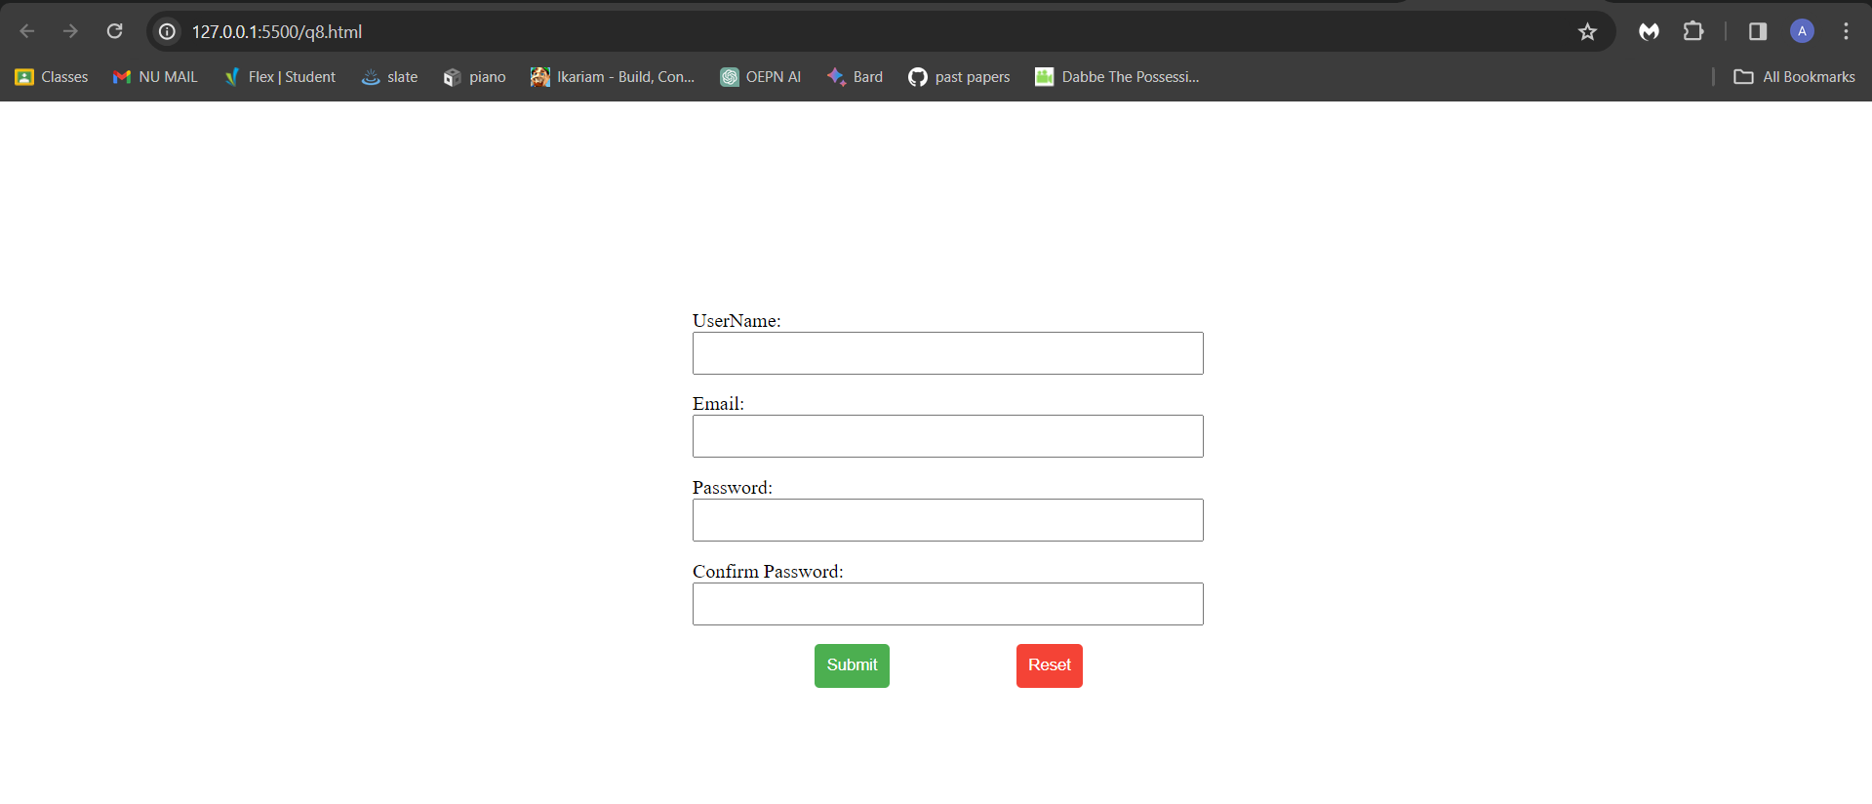

Q9) <!DOCTYPE html>

<html lang="en">

<head>

    <meta charset="UTF-8">

    <meta name="viewport" content="width=device-width, initial-scale=1.0">

    <title>Q9</title>

    <style>

        h1 {

            margin-left: 35%;

            margin-top: 2%;

            font-size: 50px;

        }

        h2 {

            margin-left: 42%;

            font-size: 30px;

        }

        form {

            /* max-width: 600px; */

            margin: 0px auto;

            margin-left: 500px;

        }

        input {

            /* width: 30%; */

            margin-bottom: 15px;

        }

        button {

            padding: 10px;

            background-color: #4caf50;

            color: white;

            border: none;

            border-radius: 4px;

            cursor: pointer;

            margin-left: 100px;

        }

        button[type="reset"] {

            background-color: #f44336;

        }

        #name {

            margin-left: 30px;

        }

        #Address {

            margin-left: 16px;

        }

        #PostCode {

            margin-left: 8px;

        }

        #e {

            margin-right: 10px;

        }

        #Email {

            margin-right: 10px;

        }

        #Tel {

            margin-left: 27px;

        }

        #rf {

            margin-left: 730px;

            margin-top: 20px;

        }

        #javascript {

            margin-left: 140px;

        }

        #js {

            margin-left: 433px;

        }

        .top {

            word-spacing: 150px;

            font-size: 25px;

        }

        #css {

            margin-left: 167px;

        }

        #install {

            height: 70px;

        }

        #sub {

            margin-left: 170px;

        }

    </style>

</head>

<body>

    <h1><b>Pete's Pizza Delivery</b></h1>

    <h2><b>Onlin Order Form</b></h2>

    <form action="#" method="post">

        <label for="name">*Name</label>

        <input type="text" name="name" id="name">

        <label for="Tel" id="Tel">*Tel</label>

        <input type="text" name="Tel" id="t">

        <label for="Email" id="e">*Email</label>

        <input type="text" name="Email" id="Email">

        <br>

        <label for="Address">*Address</label>

        <input type="text" name="Address" id="Address">

        <br>

        <label for="Town">*Town/City</label>

        <input type="text" name="Town" id="Town">

        <br>

        <label for="PostCode">*PostCode</label>

        <input type="text" name="PostCode" id="PostCode">

    </form>

    <p id="rf">*Required Fields</p>

    <form action="#" method="post">

        <h3 class="top">Topping Size extras</h3>

        <input type="radio" id="html" name="fav_language" value="HTML">

        <label for="html">HTML</label>

        <input type="radio" id="css" name="fav_language" value="CSS">

        <label for="css">CSS</label>

        <input type="checkbox" id="javascript" name="fav_language" value="JavaScript">

        <label for="javascript">JavaScript</label>

        <br>

        <input type="radio" id="html" name="fav_language" value="HTML">

        <label for="html">HTML</label>

        <input type="radio" id="css" name="fav_language" value="CSS">

        <label for="css">CSS</label>

        <input type="checkbox" id="javascript" name="fav_language" value="JavaScript">

        <label for="javascript">JavaScript</label>

        <br>

        <input type="radio" id="html" name="fav_language" value="HTML">

        <label for="html">HTML</label>

        <input type="radio" id="css" name="fav_language" value="CSS">

        <label for="css">CSS</label>

        <input type="checkbox" id="javascript" name="fav_language" value="JavaScript">

        <label for="javascript">JavaScript</label>

        <br>

        <input type="checkbox" id="js" name="fav_language" value="JavaScript">

        <label for="javascript">JavaScript</label>

    </form>

    <form action="#" method="post">

        <label for="time">Preffered Delivery Time</label>

        <input type="time">

        <br>

        <label for="install">Special Delivery Instructions</label>

        <input type="text" id="install" size="40",>

        <br>

        <button id="sub">Submit Order</button>

    </form>

</body>

</html>

